**Smart Expense Tracker**

**Phase 3: Data Modeling & Relationships**

* **Custom Object:** Expense__c
  + Fields: Vendor__c, Amount__c, Date__c, Category__c, Notes__c, Status__c.
* **Custom Object:** Expense_Report__c (for grouping multiple expenses).
* **Relationships:**
  + Employee (User) ↔ Expense__c .
  + Expense_Report__c ↔ Expense__c .
* Use Schema Builder to visualize object relationships.

**Custom Object**

**Fields And Relationships**

**Record Type**

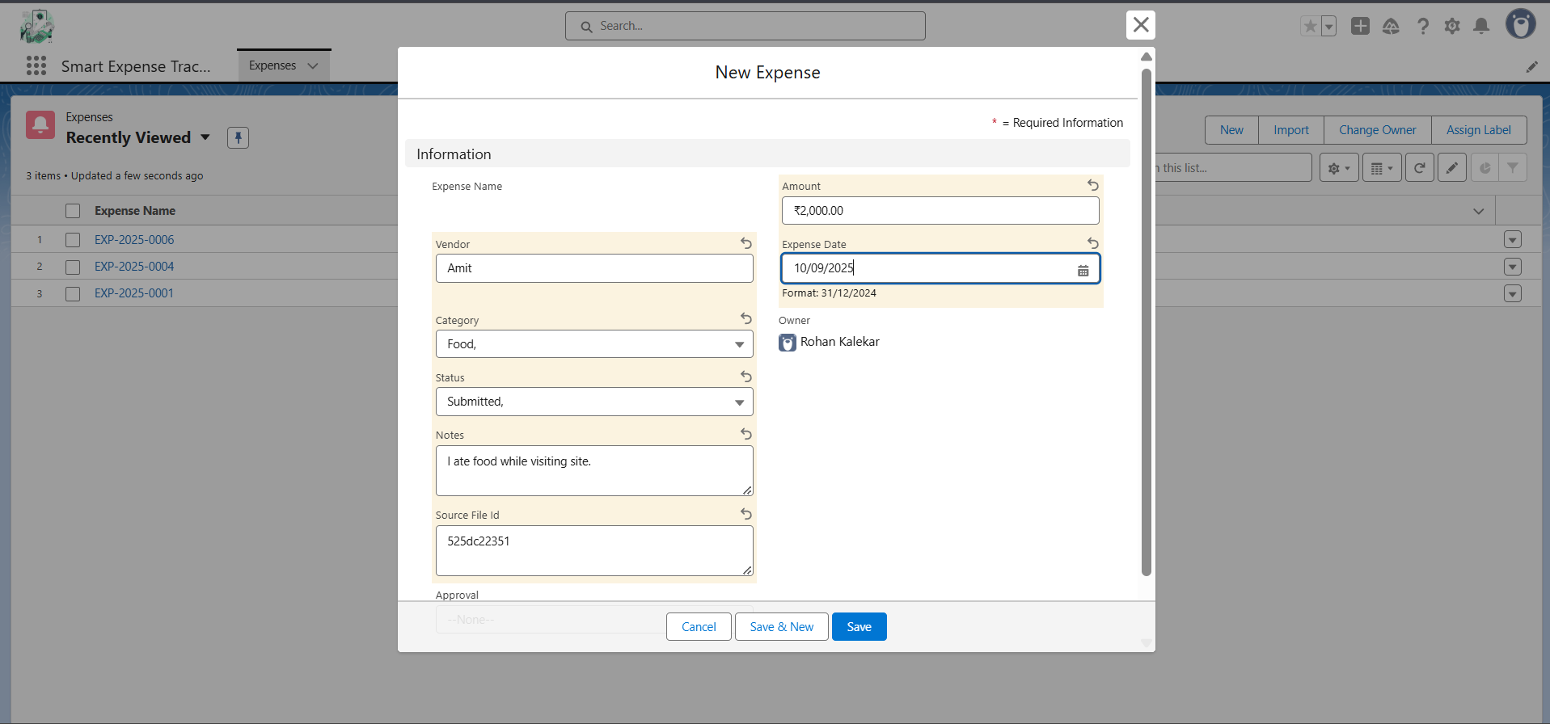

**Verification**

